Service Plan: Community Services 2024/25

Service Overview
Community Services comprises six teams focused on delivering people-centred services to the community. The diagram below sets out the teams that provide these services: Housing Solutions, Community Partnerships and Projects, Housing Strategy and Development, including Housing Business Support, Private Sector Housing, Environmental Promotion, and Community Safety, including Parking.
The services are funded from a mixture of the Council’s General Fund, Homelessness Prevention Grant Funding, and Better Care Fund, distributed by the central government, and other small pockets of funding secured through various opportunistic bidding rounds.
This year, the service plans focus only on projects that are over and above business-as-usual work. The core work of the team, therefore, is not reflected in this plan. This will include the delivery of all services described in the chart below and the delivery of actions within the key strategies and plans that form the backbone of these services, including the Housing Strategy, the Homelessness Strategy, the Countryside Vision and the North Hampshire Community Safety Partnership Plan.
Version 1 | 23 January 2024
Version 2 | 5 March 2024

Resourcing
The staffing structure for Community Services is below:
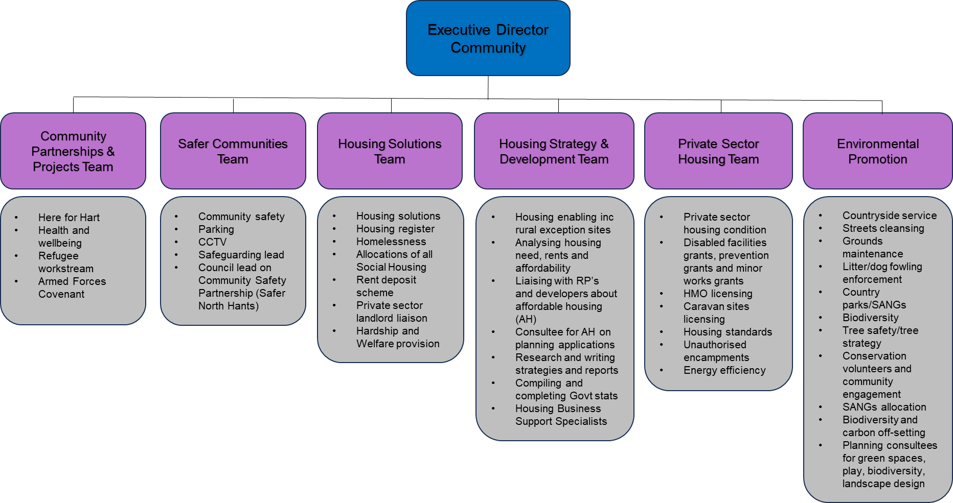
Service Priorities
The table below sets out the service priorities for 2024/25, over and above day to day service delivery.
Delivery against these is monitored via the quarterly Overview and Scrutiny Service Panel.
 | Service Priority | Link to Corporate Plan | Resources | Expected Outcomes | Target Completion Date
1 | Employment and Skills – Launch of Hart into Employment | People | Human – Community Partnerships & Projects Team | - Launch by May 2024  - To offer ongoing support to all residents, with a focus on Ukrainian households | May 2024 and ongoing
2 | Delivery of the Armed Forces Covenant Duty | People | Human – Community Partnerships & Projects Team | - Deliver Silver Employer Recognition Award | May 2024
3 | Delivery of the actions of the CCTV Review | People | Budgetary – agreed with Cabinet Jan 2024 - £15k  Human – Community Safety Team | Delivery of the following Actions identified as part of the CCTV Review undertaken in Q3 of 2023/24:  - Further data analysis on the public realm hot spot figures  - Review the current CCTV provision along Fleet Road (cameras - FL902, FL903, FL905, FL906 and FL907)  - Produce a plan for upgrading cameras with capital budget secured  - Review and further consider any other opportunities identified in the Review under section 4M  - Investigation and implementation of upgraded IP lines to replace the remaining 9 analogue lines | April 2024  April 2024  July 2024  September 2024  March 2025
4 | Delivery/installation of touchscreen parking machines | People | Capital Budget setting as agreed at Full Council Feb 2024 - £74k  Human – Parking Team | Installation of machine upgrades to 22 of the existing car park machines. | March 2025
5 | Parking review, following changes to the service during 2023 | Place | Human – Safer Communities Manager, Parking Manager & Project Officer | - Review of the Parking Service in line with best practices, including benchmarking  - Review of charging, inc benchmarking  - Review of countryside car parks | March 2025
6 | Review Housing Allocations Policy | People | Human – Housing Solutions Team and Project Officer | - Full review of allocations Policy to ensure compliance with all new legislation  - Take revised Policy (if change is needed) to Cabinet for approval | March 2025
7 | Produce an Annual Community Services Update | People  Place  Planet | Human – Housing Strategy Team | Publication of an annual update and associated promotion/communication on key outputs | July 2024
8 | Review the Preferred Partners Scheme | Place  People  Planet | Human – Strategy and Development Team and Project Officer | - Refresh the process and application requirements  - Select Registered Providers who demonstrate that they meet the requirements and standards | March 2025
9 | Heathlands remodelling project | People  Place  Planet | Human – Housing Strategy Team with Technical Specialist  Budgetary – agreed with Cabinet Jan 2023 - £80k | - Recruitment of technical specialist  - Delivery of feasibility study  - Development of project programme | March 2025 and ongoing
10 | Progressing Housing Capital Projects | Place  People | Human – Housing Strategy Team  Budgetary -  Accessible Homes - £1m  Larger Homes - £1.5m | - Purchase of wheelchair-accessible homes  - Purchase of larger 4-bedroom family homes  - Temporary accommodation for single people | March 2025 and ongoing
11 | Bring empty homes back into use (Homes for Ukraine – HCC funding) | Place  People | External funding from HCC | Recruitment of resources – Empty Homes Officer  Bringing properties back into use for occupation by Ukrainians | March 2025 and ongoing
12 | Identify biodiversity and climate change offsetting opportunities | Planet | Human – Environmental Promotion Approved Grant Funding Project with support from Earmarked Reserves | - Submit Biodiversity Strategy, with BNG financial model and costed delivery plan, to Cabinet for the approach to and delivery of BNG - subject to Government guidance  - Complete the delivery of “pilot” projects (delivery of the physical works on site) | August 2024  Sep 2024 to  Feb 2025
13 | Delivery of (Phase 2) Ecological Mitigation works at Fleet Pond | Planet | Human – Environmental Promotion Approved Capital Earmarked Reserves. | Fleet Pond Improvement Strategy for the delivery of ecological mitigation and improvement works to be produced and approved by Cabinet | March 2025
14 | Grounds & Street Care Audit | Place  Planet | Human Will need support from GIS officer | Mapping Grounds Maintenance areas to develop a schedule of rates with consideration of biodiversity and carbon footprint considered | March 2025
15 | Litter Enforcement review | Place  Planet | Human | Options appraisal for the future provision of the Litter Enforcement Service. | July 2025

Performance indicators and targets
KPI | Description | Annual Target
1 | Number of households receiving acute intervention | INFO ONLY
2 | Number of households prevented or relived from becoming homeless | 50% of all presentations recorded on HCLIC (Homelessness Database)
3 | Number of families in B&B for more than 6 weeks | zero
4 | Number housed into the PRS (cumulative) | 30
5 | Number of gross affordable homes delivered (cumulative) | 100 (INFO ONLY)
6 | % Disabled Facilities Grant spent against budget | 100%
7 | No. of DFGs and Prevention Grants completed | 80
8 | Community events attended to promote service accessibility, across Community including Countryside | 16
9 | Number of countryside “Green Flags Awards” held | 5
10 | % Countryside major sites with current Management Plan | 90%
11 | Number of grass verge cuts per annum (typically undertaken between March –October) | 9
12 | % Watercourses cleared out each year | 75%
13 | Hedge and shrubs maintained to service standard | 2 cuts a year
14 | % of adopted roads swept within the 15-week cycle | 75%
15 | Of the 585 bins we own (1200 empties a month) no more than 5 missed a month | 60 missed bins
16 | Provide system resilience levels of above 98% per calendar year for the CCTV control room system. The measurements will be hourly downtime as a % over 365 days | The Control Room is manned 24/7, so is there any point in keeping this in as data will always be 0 unless there is a civil emergency?
17 | Illustration of activity being picked up and issues with CCTV cameras as follows:  - breakdown of incidents per camera  - camera faults identified | INFO ONLY
18 | Report requests for CCTV footage, by whom and in what locations | INFO ONLY

