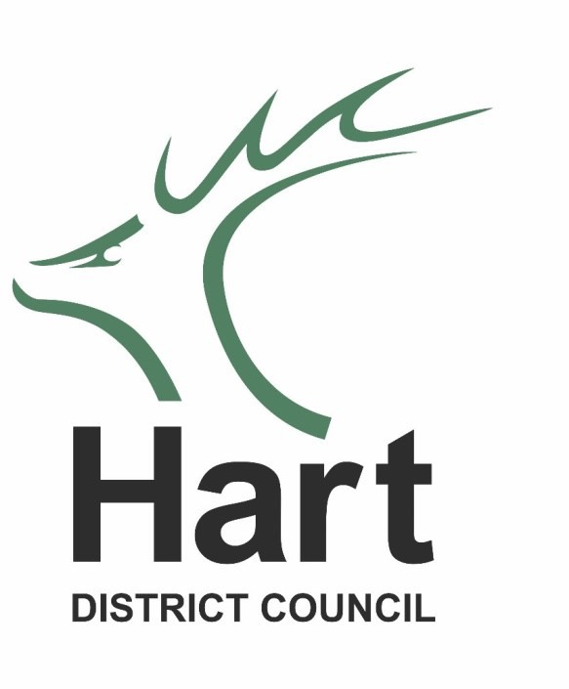

Public Participation at

Cabinet and Overview and Scrutiny Committee

**The public participation scheme allows you to voice opinions and objections at these meetings**

**Meetings start at 7pm**

# At which meetings may I speak?

You may speak at scheduled meetings – time permitting of course.

# Who may speak?

Anyone (excluding Councillors) who normally lives or works in the District, provided they are present at the meeting when the Chairman of the meeting calls their name.

# How much time will speakers be allowed?

A total of four minutes will be allocated to public participation on each agenda item with individuals limited to two minutes each. For the sake of fairness there must be time to hear from those “in favour” and “those against”.

Time is limited so we encourage the appointment of spokespersons to represent groups of people who wish to make similar points.

# Can I speak on any matter?

No. Speakers will be allowed to speak only on matters that appear on the Agenda of the Cabinet or Overview and Scrutiny Committee.

NB Comments on applications for grant aid and applications for any licence are not permitted.

# What do I do if I decide I want to speak?

If you would like to address the **Cabinet** or the **Overview and Scrutiny Committee** then please contact our Committee Services Section at least 2 clear working days prior to the meeting, ie if the meeting is on a Thursday, questions must be received by 5pm on the preceding Monday.

Please note you may only make statements at Cabinet. You can direct questions to Full Council. Questions or statements can be put to the Overview and Scrutiny Committee.

# What happens at the meeting?

At the appropriate time the Chairman will invite each person to make his or her comment.

# How to Apply:

Applications should be made in writing and provide the following information: Name, Contact Number and brief outline of your statement/question.

Please send your statement/question to: [committeeservices@hart.gov.uk](mailto:committeeservices@hart.gov.uk) or write to us at Committee Services, Hart District Council, Civic Offices, Harlington Way, Fleet GU51 4AE.

Other leaflets with information on public participation at the Development Management Committee and Full Council are available.

If you have any queries, then please contact Committee Services email: [committeeservices@hart.gov.uk](mailto:committeeservices@hart.gov.uk)